

Vidya Pratishthan’s
Kamalnayan Bajaj Institute of Engineering
and Technology, Baramati-413133.
Pune University

A

Project Report on

“Employee Payroll Management System”

In partial fulfillment of the requirements for award of
The degree of
BACHELOR IN ENGINEERING
BY

Divya Lokhande ROLL NO: 2431041
Tejasvini shelar ROLL NO: 2431071
tanuja more ROLL NO: 2431072

Project Guide
Mr. M. D. Shelar

T.E Computer. (Sem-V) 2024-2025

Certificate

This is to certify that work on the project report “Employee Payroll Management System” presented by “Divya Lokhande , Tejasvini Shelar and Tanuja More” in partial fulfillment of the requirement for the award of Bachelor of Computeer Engineering to the VPKBIET, Baramati has been carried out under my guidance.
To the best of my knowledge and belief the matter presented in this report has not been submitted earlier or copied from anywhere.

Mr. M.D.Shelar
Project Guide

ACKNOWLEDGEMENT

In Our endeavor to achieve the success in completing our project “Employee Payroll Management System ” in the Third Year Engineering in Computer Engineering We greatly thankful to the people without whose assistance, guidance and efforts we would not be able to complete out project successfully.

We express with our heartfelt gratitude to our guide ‘Mr. M. D. Shelar’ who through his experience, encouragement and constant guidance helped us to shape our project to the present stage without his help our project could not be completed.

Finally we would like to thank our college’s teaching and non-teaching staff of our department for co-ordinating with us.

DIVYA LOKHANDE
Tejasvini Shelar
Tanuja More

ABSTRACT

As a part of Project we are going to create the software that helps in Company. In this project we are trying to implement the software that will help both the Employee & the Manager to get the information about the Payroll data.
This project is basically created to reduce the work of Manager. In this project, we are also trying to record the information about the employees who are currently working in our company . This will also help the manager. This Project will also hide Details about the records.

INDEX

Sr. No. | Topic Name | Page No.
1. | Introduction | 9
2. | Introduction to Project | 11
3. | Database Design | 12
4. | ERD Diagram | 17
5. | Output Screens | 19
6. | User Manual | 24
7. | Conclusion | 27
8. | Bibliography | 29

1 Introduction

Need of computerization
We live in a computer age. Most of our day-to-day activities are beginning influenced by the use of computer; it has become necessary for every one to have basic knowledge of computer. The computer field as a whole continues to experience tremendous growth of personal computer, which were introduced in early 1980’s have become popular and being widely used in offices and homes. The usefulness of computer has growth steadily with the introduction of powerful and versatile computer software programs, while in areas like science and technology improvements are unimaginative.

Some people are enormously believed that computer’s can only work on arithmetic operations. The use can work on any kind of data – text, numeric, images, sound and video clipping etc.

The computer is characterized by incredible speed, great accuracy, high consistency and high amount of storage capacity.

2 Introductions to the Project
I have designed my project “Employee Payroll Management System.” The project is used by company officials to make payroll processes easier and more efficient. Through this project, we can create new employee records, search for specific employee information, enter payroll transactions such as salary payments, deductions, bonuses, and display balances, etc.
One of the key features of this project is its user-friendly interface. It helps to maintain records of all employees and their payroll transactions, which are essential for any organization.
This project provides significant support to company officials, who are often busy with their tasks. Manually managing payroll records is time-consuming, but my project saves a lot of time, which is as important as saving money.
In this project, Access is used as the back-end for storing data in the database. Access is a powerful database management package, so we can efficiently secure the data as well as take backups whenever necessary.

3 Database Design

This table gives the detail information of the Company Employee.

Master table

Field | Type | Size | Description
Employee_id | Number | 14 | It is a unique field, which identify particular Employee
NIC | Number | 12 | It store the NIC Number of Employee
name | Text | 30 characters | It stores the first and last name of the Employee.
Address | Text | 50 character | It stores the Address of Employee
City | Text | 8 | It stores City of Employee
Gender | Text | 5 character | It stores the gender of the Employee.
Contact Number | Number | 20 | It Stored the Contact Number of Employee

This table gives the detail information about the Salary of a Employee

Master1 table

Field | Type | Size | Description
Salary Amount | Number | 14 | It is display the Salary Amount of Employee
Salary Type | Text | 12 | It identify the Salary Type of a Employee
EPF | Number | 30 | Employer's contribution to your EPF account is exempt from tax
TAX | Number | 15 | Employers are mandated to deduct tax at source from an employee's salary at the time of payment (at the source).
PAYE | Number | 20 | Pay As You Earn is a term used in two primary ways: (1) as a means of taxation for income tax to be withheld by employers and (2) student loan repayments based on an income plan.
Performance Bolus | Number | 25 | It stores the years for each the FD is done
Food Allowance | Number | 25 | specific amount of money in the form of coupons or card provided to employees by employers.
Travel Allowance | Number | 25 | A financial provision provided to employees by their employers to cover expenses incurred during business-related travel.

This table gives the information about Company and Leave Details of a Employee.

Company and Leave Info table

Field | Type | Size | Description
Department Name | Test | 20 Character | It Stored the Department Name of Employee.
Date of Joining | Date | 15 | It display the date of joining
Designation | Text | 50 characters | Its contains the Designation part of our Company.
Optional Leave | Date | 8 | It stores the date of Optional Leave
Casual Leave | Date | 8 | It stores the date of Casual Leave
Annual Leave | Date | 8 | It stores the date of Annual Leave

4 ERD Diagram
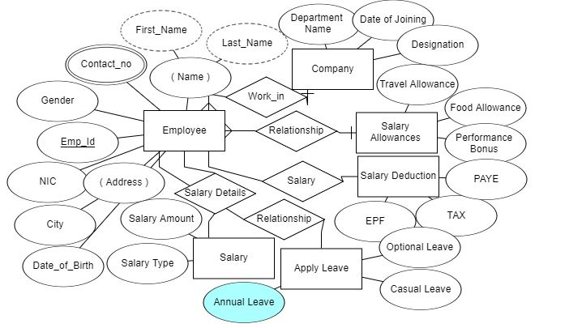

TECHNICAL SPECIFICATION:

HARDWARE REQUIRED:-

- CPU processor :-P3

- RAM -128 MB and above

- Hard Disk -40 GB and above

- Output device:-monitor,printer.

SOFTWARE REQUIREMENTS:-

- Operating system:-Windows XP and above.

- Front end:-JAVA

- Back end:- Mysql

6 Output Screens
Login Screen
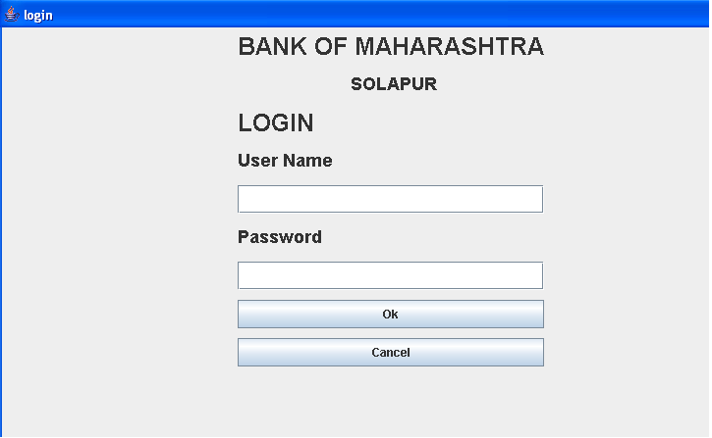
Main Menu Screen
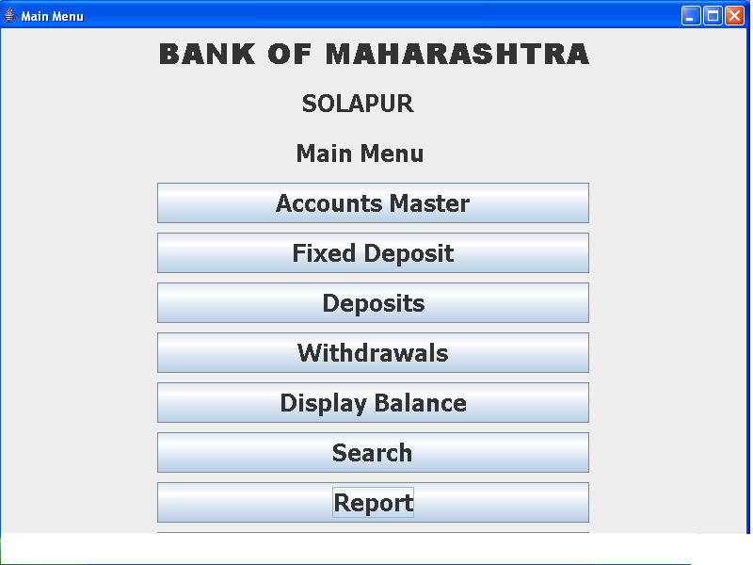

Accounts Master
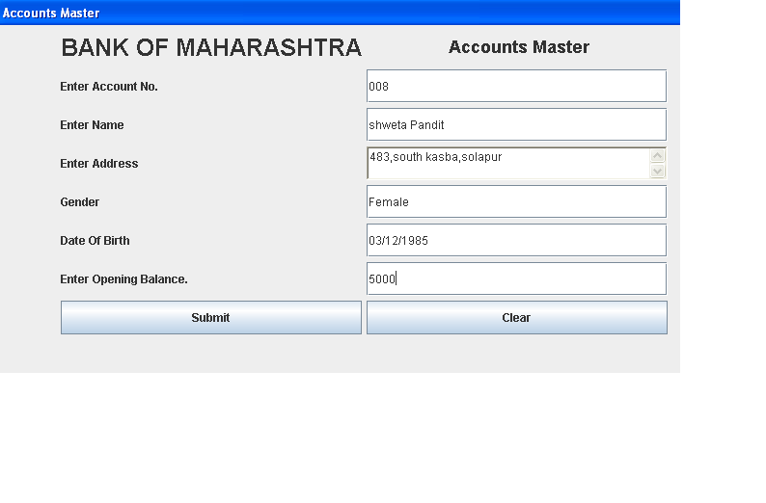
Fixed Deposits Screen
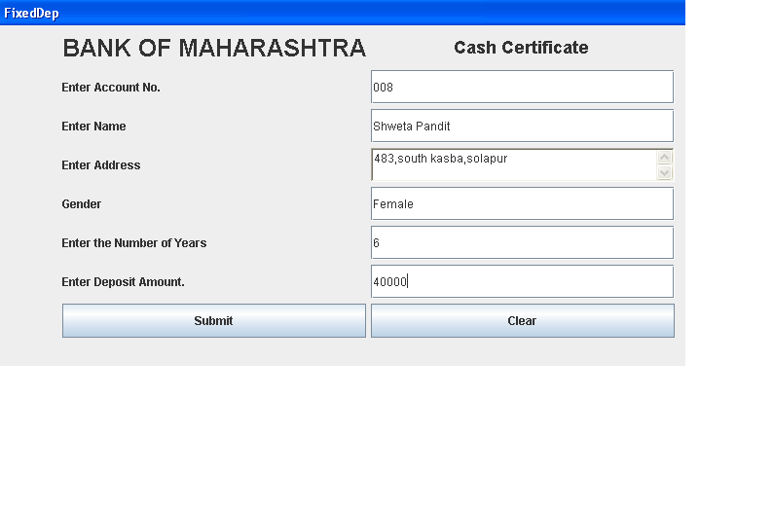
Deposit Transaction Screen
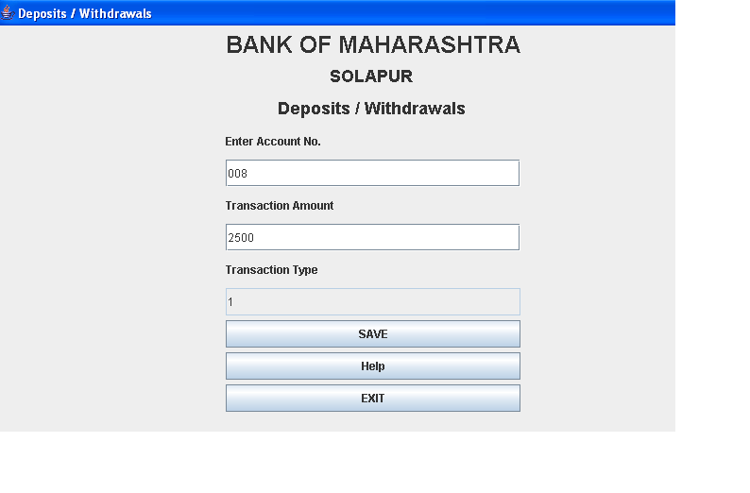
Withdrawal Transaction Screen
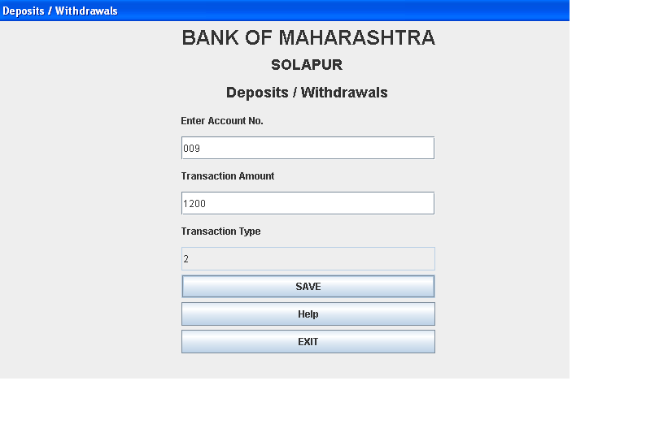
Display Balance Screen
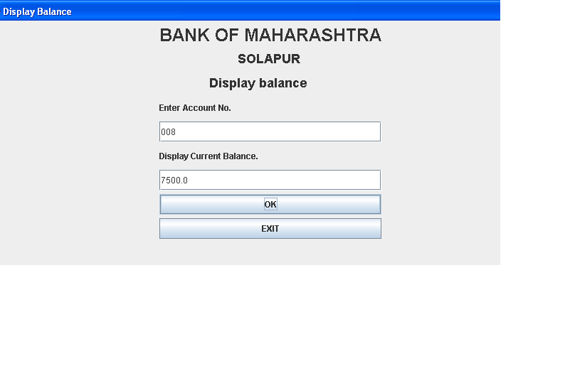
Search Screen
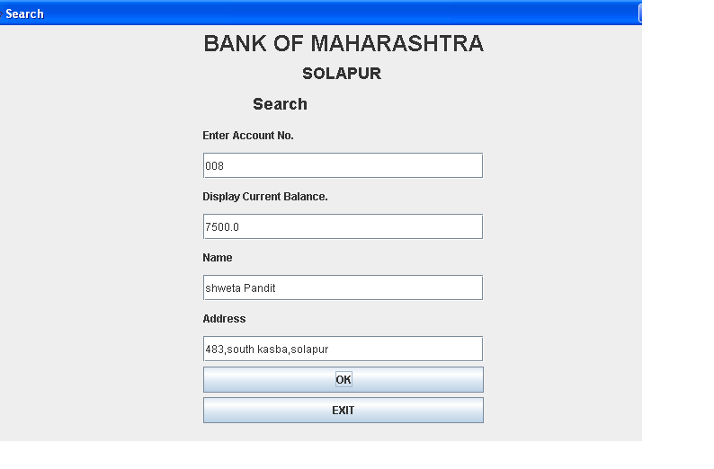

7 USER MANUAL
The application software “Employee Payroll Management System” is developed in Java as a front-end and Microsoft access(Mysql) as backend.
In the Employee Payroll Management System, users interact with the software through a well-designed interface that ensures clarity and ease of use. The system aims to enhance user satisfaction by streamlining payroll processes and providing quick access to essential payroll information. Below is a detailed description of the Main Menu, which includes the following tabs:

Main Menu
- Employee Master
- Bonuses and Deductions
- Salary Deposits
- Salary Withdrawals
- Display Salary
- Search Employee
- Generate Report

1) Employee Master Menu:
This is the form through which the user (typically an HR or payroll administrator) can add new employee information when creating an employee profile. The user enters key details such as the employee’s name, ID, job role, department, salary, tax information, and other employment-related data. The starting salary or opening balance for payroll is also entered here. This data is saved in the Employee_Master table, which stores all employee-related information.

2) Bonuses and Deductions Menu:
Through this form, the user can enter details about any bonuses (e.g., performance bonuses, holiday bonuses) or deductions (e.g., taxes, loan payments, insurance) for an employee. The bonus amount or deduction amount is saved in the Bonuses_Deductions table. This ensures that any additional earnings or deductions are reflected in the employee’s payroll.

3) Salary Deposits Menu:
This form allows the user to input the salary or wages deposited into an employee’s account. The salary amount is recorded in the Payroll_Transactions table. At the same time, the employee’s current balance in the Employee_Master table is updated to reflect the deposit, which is the net salary after deductions.

4) Salary Withdrawals Menu:
In this menu, the user can enter details if there are any withdrawals or deductions from the employee’s salary (e.g., penalties or additional deductions). This information is logged in the Payroll_Transactions table, and the Employee_Master table is updated to adjust the employee's balance accordingly.

5) Display Salary Menu:
Using this form, the user can view an employee’s current salary balance and details by entering the employee’s ID. This provides a quick summary of the employee's salary after deposits and deductions, which can be accessed at any time.

6) Search Employee Menu:
Through this menu, the user can search for a particular employee's details using their employee ID. This feature allows HR staff to quickly retrieve information about the employee, including personal details, salary, bonuses, and deductions.

7) Generate Report Menu:
Using this menu, the user can generate a report that provides details about the last payroll transaction for a specific employee. This report is saved in a text file (e.g., payroll.txt) in the same folder as the system application. The report includes transaction details such as the gross salary, deductions, net salary, and the date of the last payroll entry.
Each menu in the Employee Payroll Management System ensures that users can manage payroll processes efficiently, allowing for quick data entry, real-time salary updates, and access to reports. The system is designed to maintain accuracy in payroll management and offer transparency in employee financial records.

7 Conclusion

I designed this package to the best of my ability.

After the development of Employee Payroll Management System
Working of the system showed that it deal with
Following aspects:

1. Create Accounts of Employees and Enter Their Detailed Information as Well as Current Salary.

2. Enter Information About Bonuses or Fixed Deductions Made by the Company.

3. Add Amount to the Current Salary if Bonuses or Allowances are Awarded.

4. Subtract Amounts From the Salary for Deductions such as Taxes or Penalties.

5. Display the Current Salary and Pay History of an Employee Anytime.

6. Search for a Particular Employee’s Details Using Their Employee ID.

7. Take the print of a Payroll details of a Employee.

BIBLOGRAPHY

- Gupta, S. (2019). Human Resource Management: Concepts and Practices. SAGE Publications.
This book provides an overview of human resource management, including payroll systems as a core component.

2 . Mathis, R. L., Jackson, J. H., Valentine, S. R. (2016). Human Resource Management (15th ed.). Cengage Learning.

A detailed examination of HR functions, including payroll management, compensation, and benefits administration.

3 . Laudon, K. C., & Laudon, J. P. (2017). Management Information Systems: Managing the Digital Firm (15th ed.). Pearson.

Discusses the role of payroll management systems within broader management information systems.

